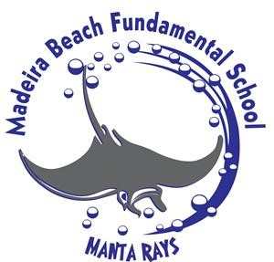

**Madeira Beach Fundamental K-8 Tour Dates:**

**Discovery Night - Tuesday, November 15, 2022**  
5:30 – 7:00 pm  

Families are welcome to tour the campus on their own from 5:30pm – 6pm. A formal information meeting will begin promptly at 6pm in the Middle School Cafeteria. There will be school staff and volunteers to direct families as they arrive on campus.

October 19, 2022 at 8:30 a.m.

November 2, 2022 at 8:30 a.m.

November 30, 2022 at 8:30 a.m.

December 14, 2022 at 8:30 a.m.

January 11, 2023 at 8:30 a.m.

**Other Important Dates & Information:**

**Pinellas County Schools Choice Fairs**

**North County DAP Fair  
October 18th, 6:00 - 7:30 pm at Dunedin High, 1651 Pinehurst Rd, Dunedin**

**All County DAP Fair  
October 22nd, 9:00 - 11:00 am at Largo High, 410 Missouri Ave., Largo**

**South County DAP Fair  
October 27th, 6:00 - 7:30  PM at Boca Ciega High, 924 58th St S, Gulfport**

**January 10 – 20, 2023 – Application Period**